Web Development Lesson Plan

|  |  |  |
| --- | --- | --- |
| Session: 2 | Topic: Setting up your virtual envrionment | Day: 2 |

|  |
| --- |
| Lesson Objective:  This exercise will...   * Teach students how to setup their own virtual environment.   The purpose of this lesson is also that   * Students can understand basic commands. |
| Materials Needed:   * VS Code * Internet Access |
| Agenda:   1. Download virtual environment (5 minutes) 2. Setup your first virtual environment (10 minutes) |
| Procedure:  Student can do this fully independently by reading the instructions, or someone can read the instructions to make sure the task is understood before doing the activity. The reflection part can be done with guided instructions, or in pairs with other students if available to compare notes. |
| Assessment/Check for learning:   * Students can identify concrete things that they missed in their observation (note that this is not a bad thing, the purpose of this lesson is to realize that intentionally looking for information comes with the ‘penalty’ of reduced attention to other things. |

What if:

* Student has already shown proficiency in that skill?
  + Pick a movie or episode in which a lot of things are happening, so that there are more things for the student to keep track of.
* Student is having a hard day and needs special accommodations?
  + Pick a movie or episode in which only a few things are happening, so that there are less things for the student to keep track of.
  + Instead of writing, the student can also take spoken notes with an audio recorder. This will be a bit trickier in the second part but audio in the movie can be supported with subtitles.

NOTES:

* Duration is approximately 50 minutes; can be adjusted by shortening the duration of the film clip. Less than 10 minutes is not recommended unless really necessary.

**Instructions**

**Download virtual environment (15 minutes)**

Step 1:

To make your own virtual environment open a new VS Code window. Then open a new terminal.

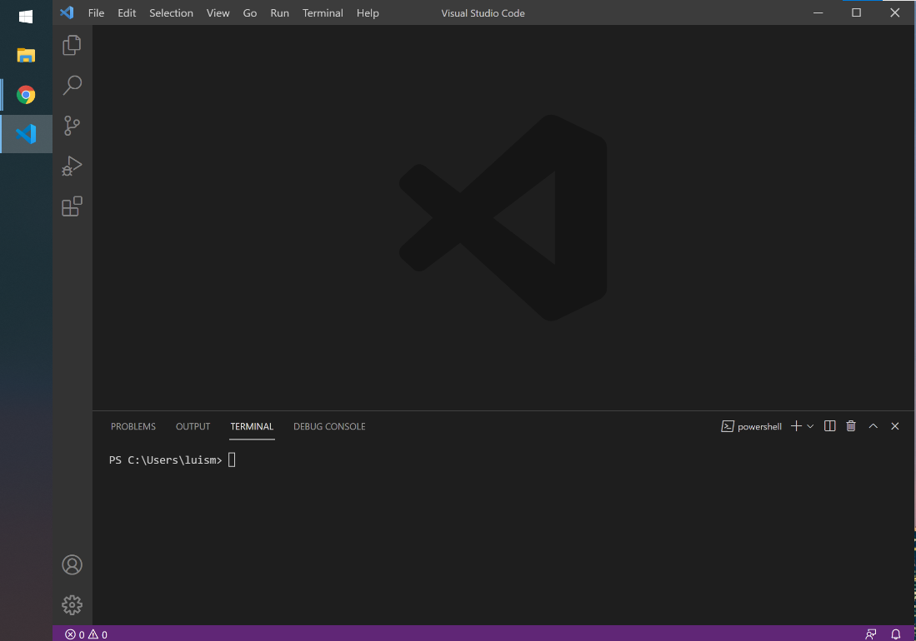

Step 2:

Make new folder called “Lesson8”. Use the **mkdir** command:

mkdir Lesson8

Step 3:

Next, change directory into Lesson8. Use the **cd** command:

cd Lesson8

Step 4:

Now that we are inside of Lesson8 folder, let’s install the virtual environment management tool on the computer. **You will run this command once.** This command will allow you to create your own virtual environments, but you will not need to run this command to start a new environment. Run the following command:

pip3 install virtualenv

You should see the following (ignore the warning):

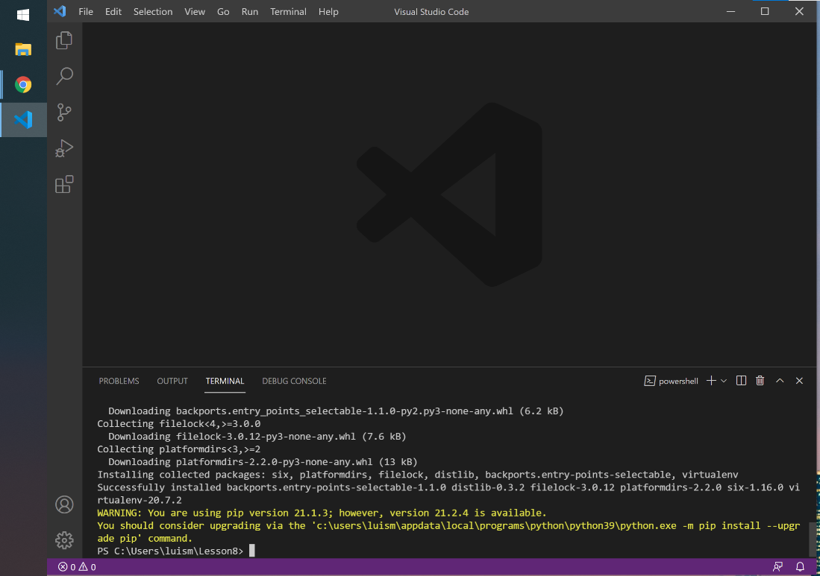

Step 5:

You have successfully installed the virtual environment tool. You will need to keep your VS Code open for the next section.

**Setup your first virtual environment (20 minutes)**

Step 1:

Now that you have installed the virtual environment tool you will create your own virtual environment.

Step 2:

Inside Lesson8 we will initiate a virtual environment. The following command will create a virtual environment:

virtualenv env –p python3

In the line above, the second word “**env”** is the name of your virtual environment, this name can be changed to anything you like. For example, to name the environment “fun” you would type the following command: “virtualenv fun –p python3”. You can practice this in a different environment, but for now we will continue with the virtual environment called **“env”**

After you run the highlighted command above, you will see this:

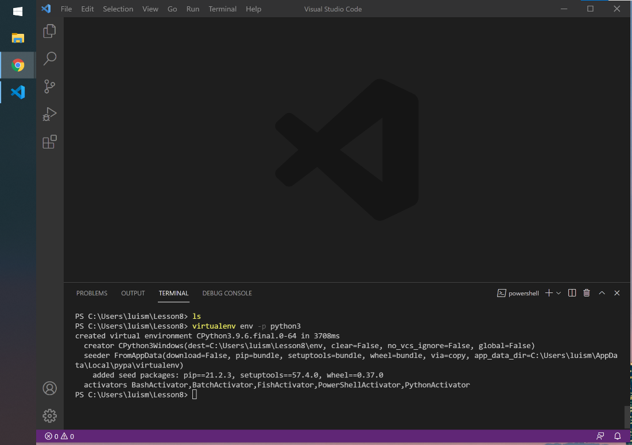

Step 3:

The command above has created a new folder called “env”. Type **ls** in the terminal and you will see “env”. **You will never need to change any files within the virtual environment folder.**

Step 4:

Next, let’s activate the virtual environment. Currently the virtual environment is dormant, so it is not managing anything. We have to activate it with the following command:

source env/bin/activate

Once you have run the command above you should see an “env” tag at the start of your command line (see below)

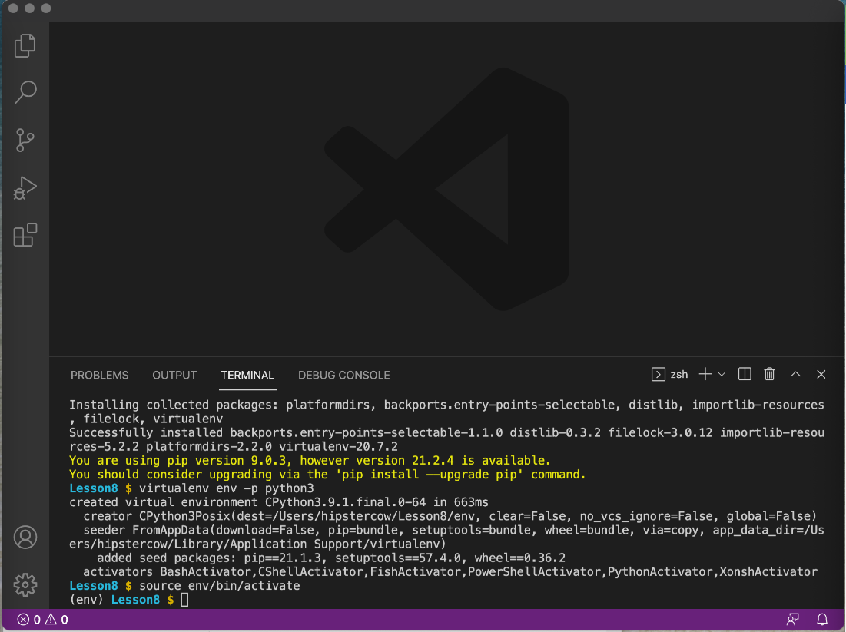

Note: You will need to activate your environment each time you are working on a development project.

**\***If the above command did not work, please view the following tutorial:

<https://code.visualstudio.com/docs/python/environments#_global-virtual-and-conda-environments>

Step 5:

You have now successfully created your first virtual environment. To turn off the virtual envrionment you can type:

deactivate

Once you deactivate the virtual environment you will no longer see the “env” tag in front of your command line.

In the following lesson you will create another virtual environment and download the Django framework.